**Problem Statement:**

**You work for XYZ Corporation. Your corporation wants to launch a new**

**web-based application and they do not want their servers to be running all the**

**time. It should also be managed by AWS. Implement suitable solutions.**

**Tasks To Be Performed:**

**1. Create a sample Python Lambda function.**

**2. Set the Lambda Trigger as SQS and send a message to test invocations**.

1. Created SQS Queue

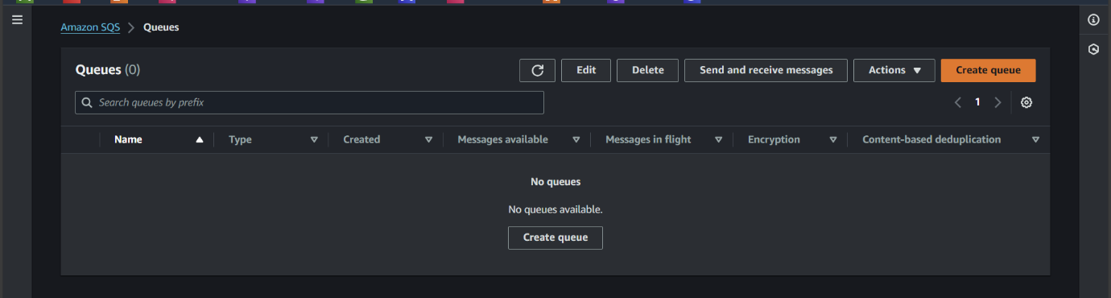

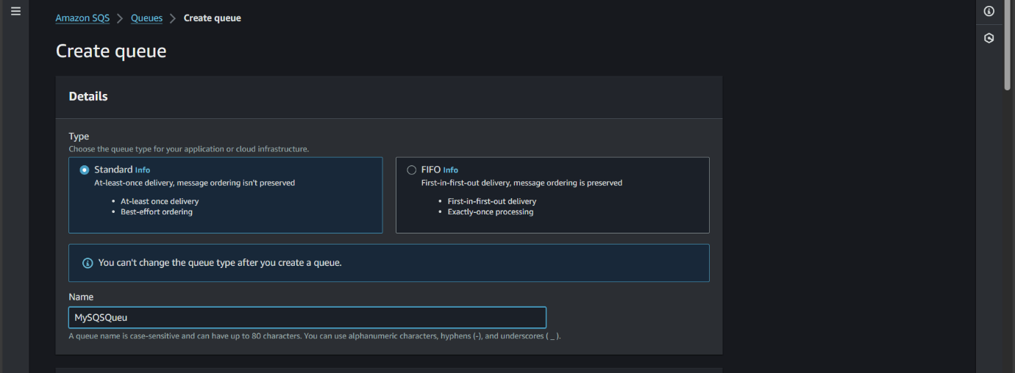

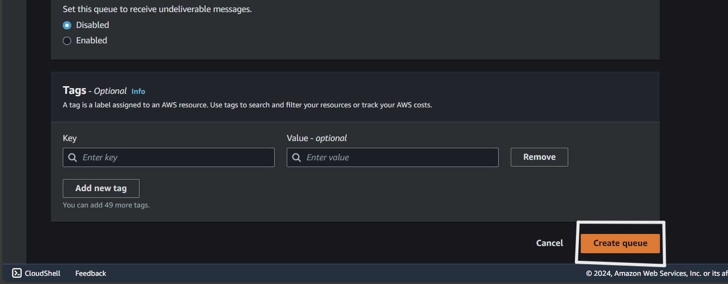

1. Create a lambda function

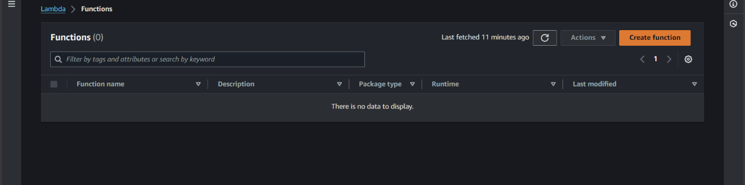

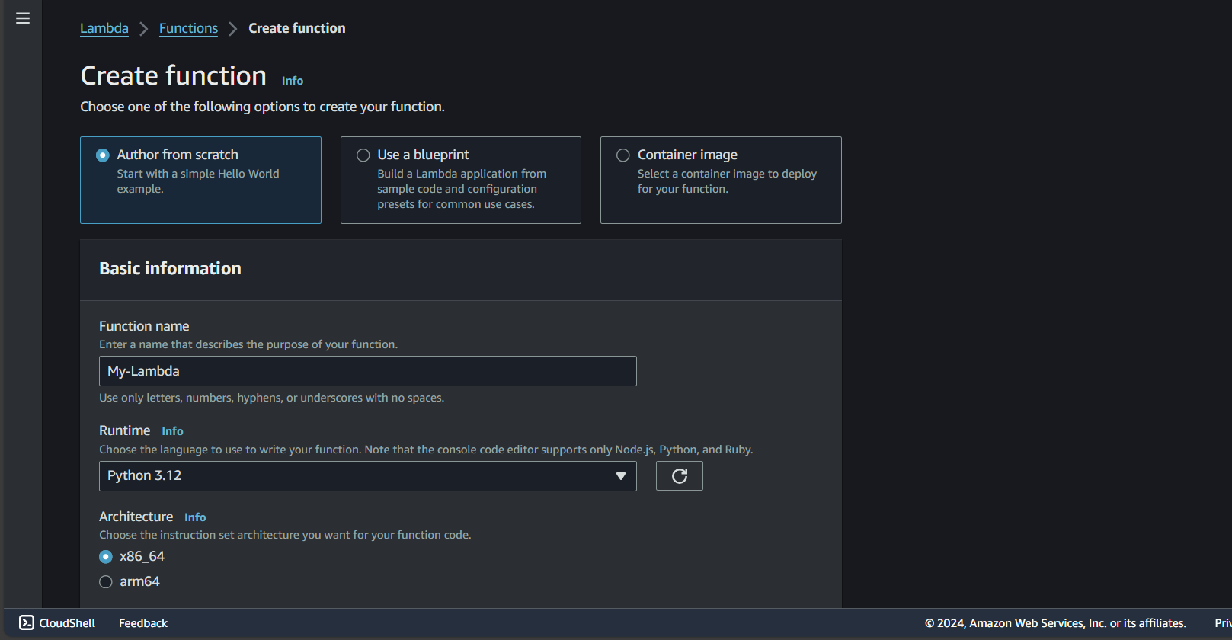

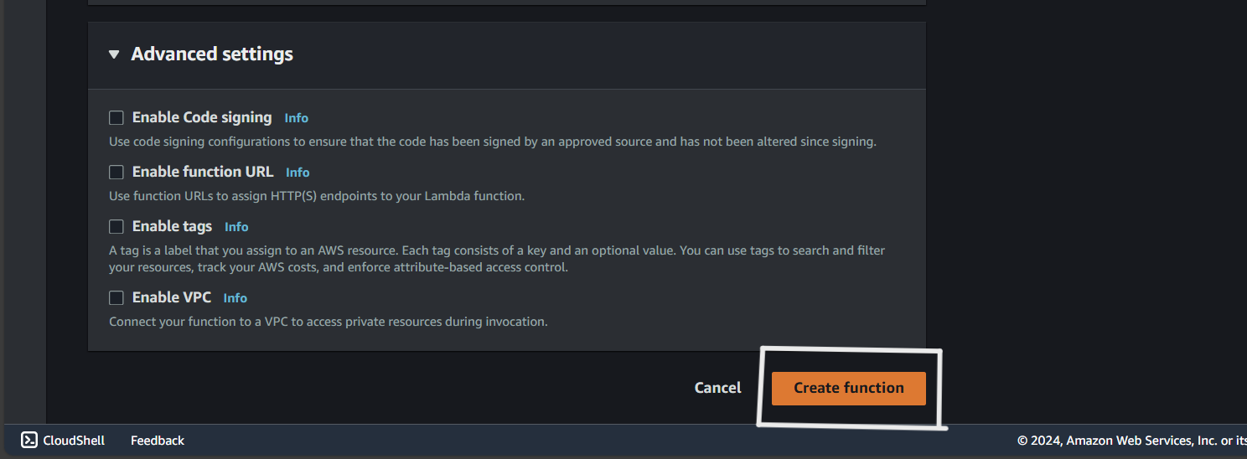

Under function code write the code

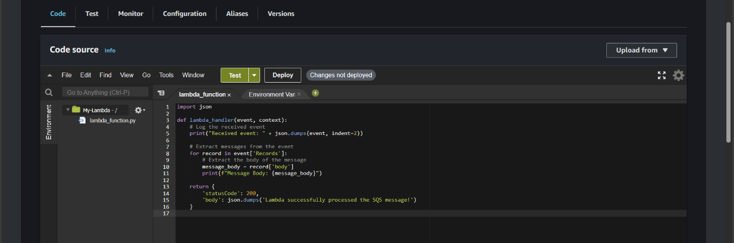

1. Grant lambda access to SQS

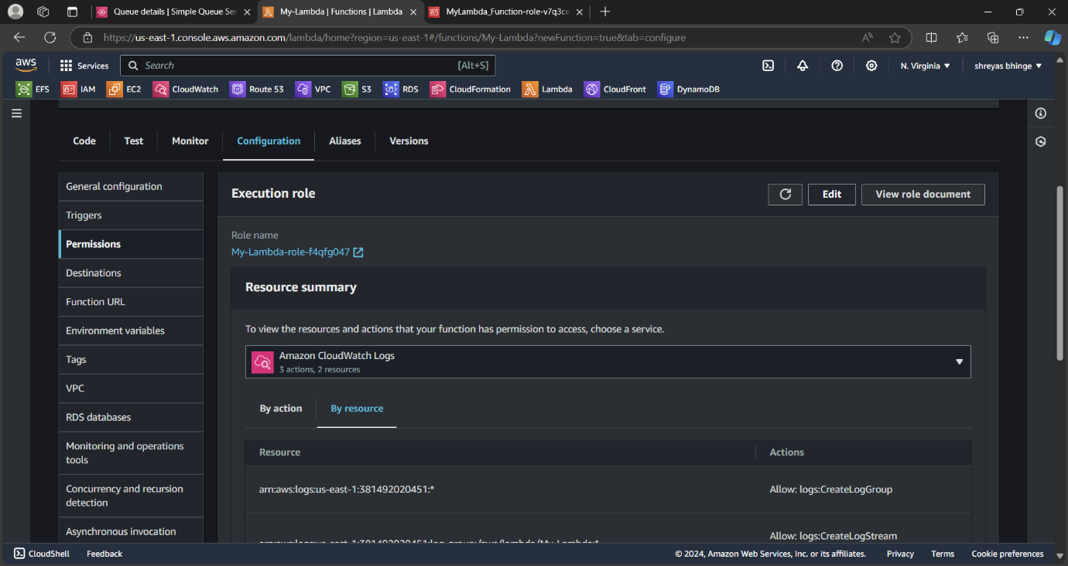

Click on Add permission

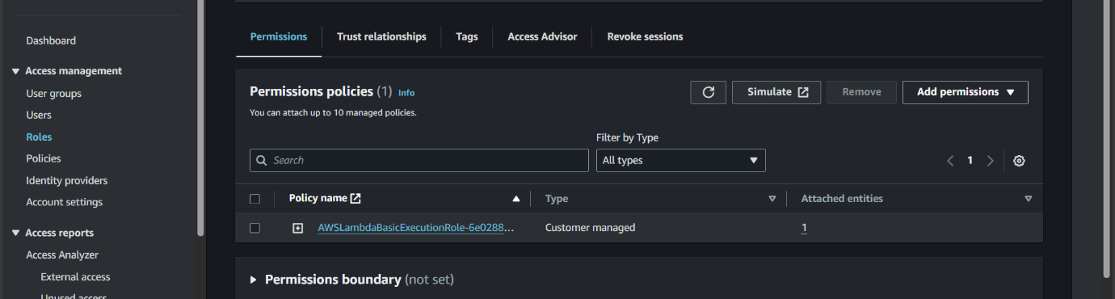

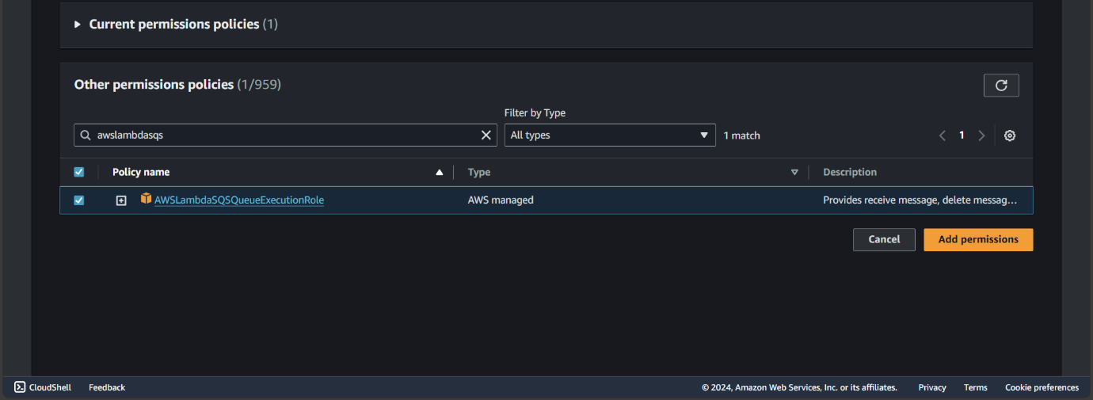

1. Add Trigger

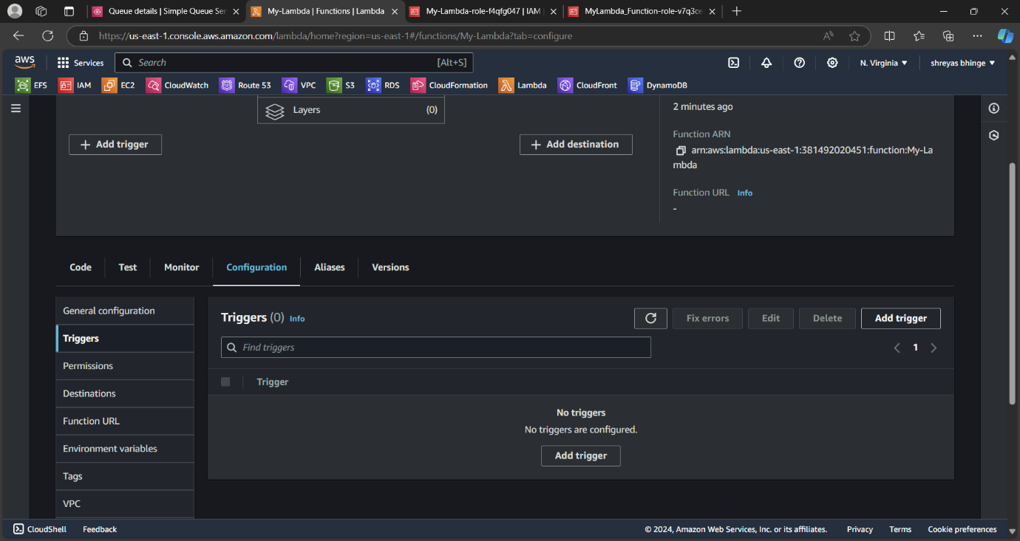

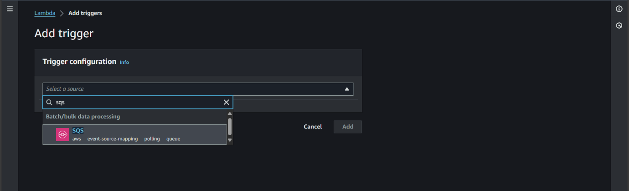

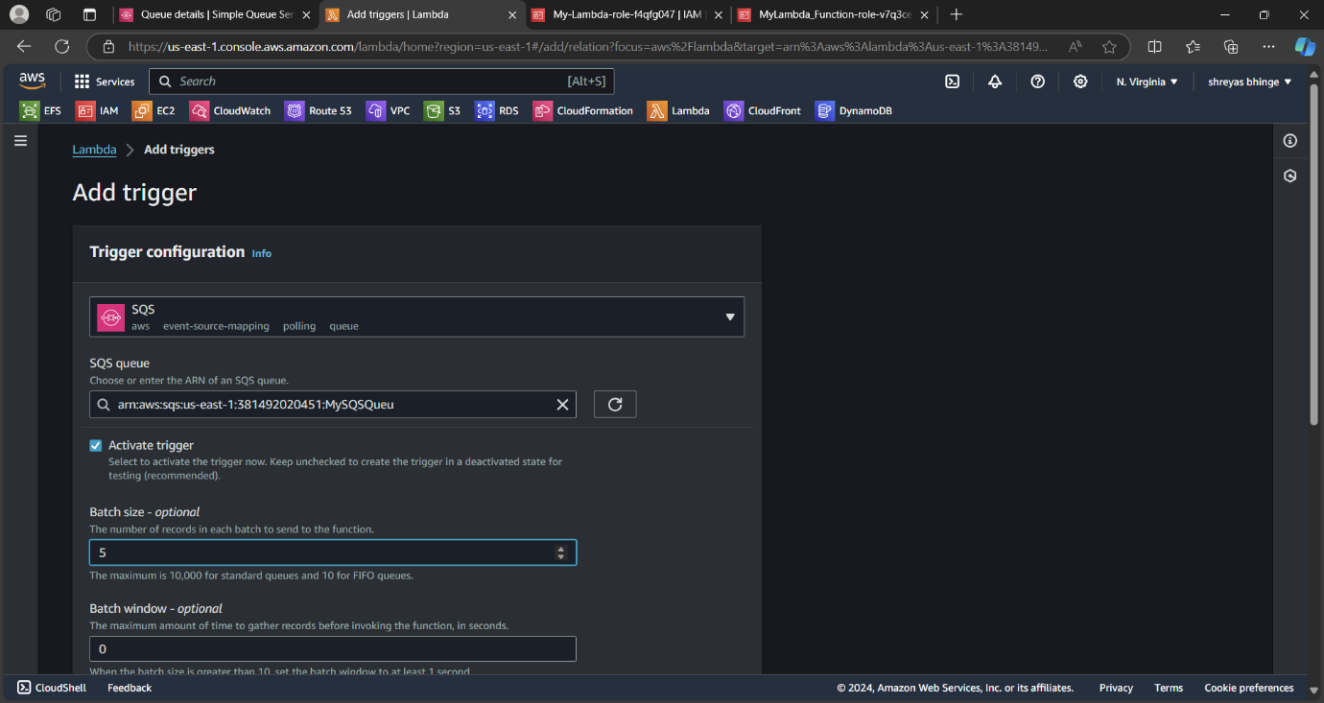

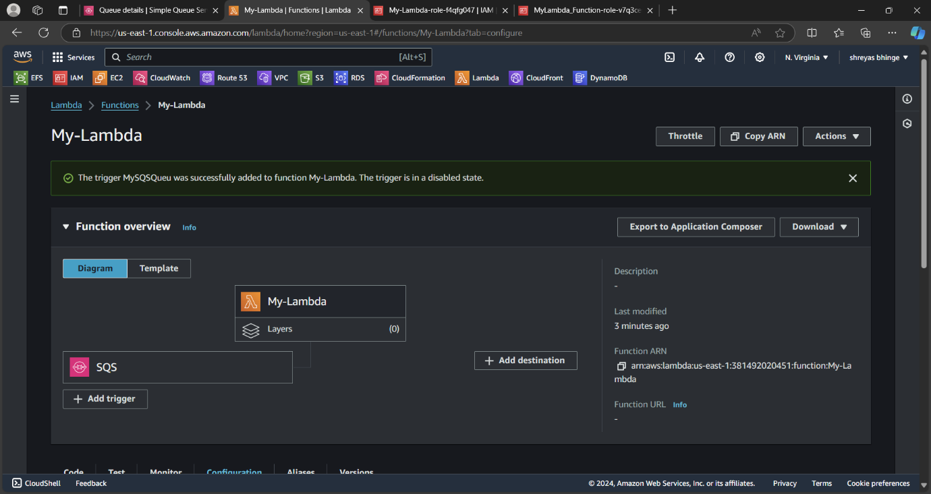

Go to SQS and click On “Send and Receive Messages”

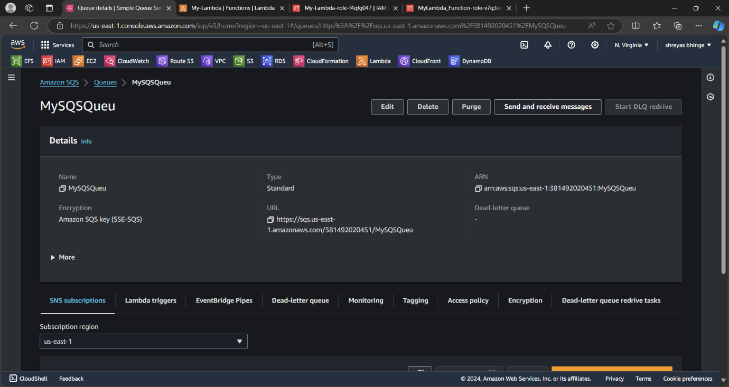

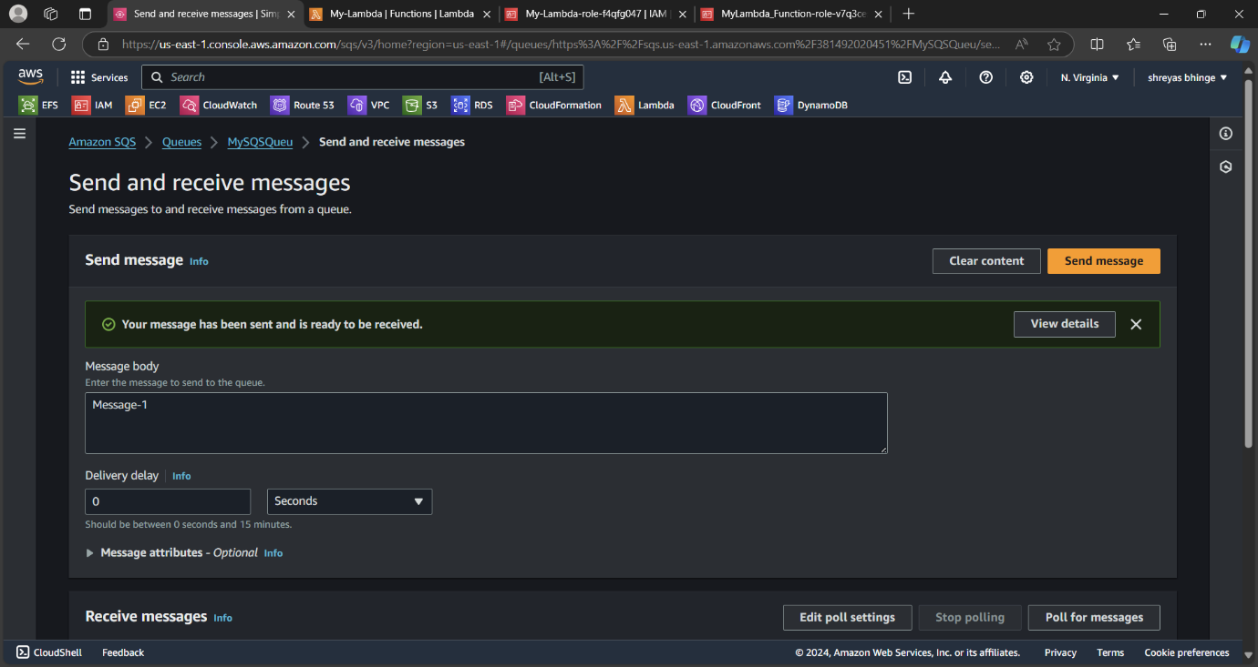

Go to Lambda function under Monitor section

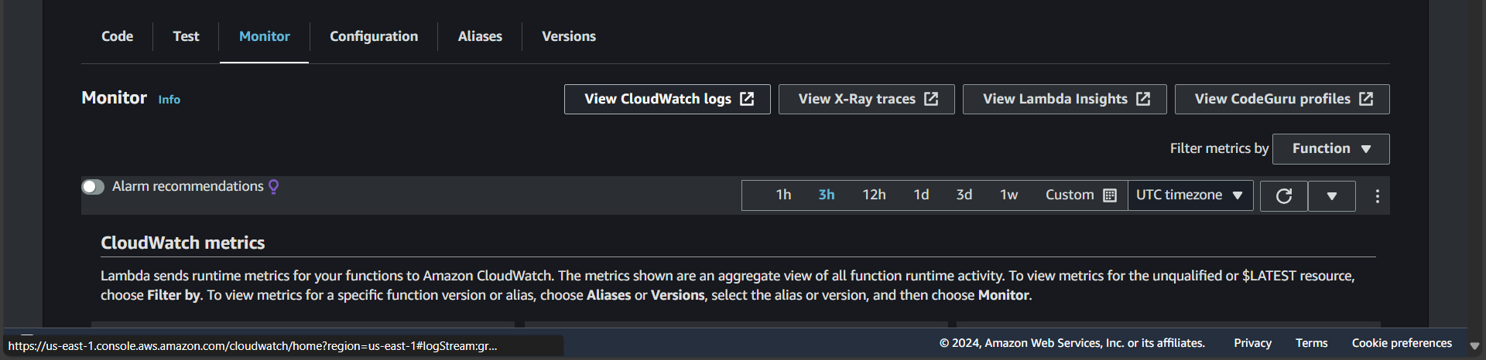

Click on View CloudWatch Log

